

# **CITY COLLEGE PLYMOUTH**

in conjunction with

## **PLYMOUTH UNIVERSITY**

**Assignment Brief**

|  |  |
| --- | --- |
| Student Number | 10715644 |
| Module Number | SDFD105 |
| Module Title | Human Computer Interface |
| Lecturer Name | Dr Martin Stanton |
| Assignment Number | Two of Two |
| Assignment Title | HCI Design and Evaluation |
| Assignment Format | Report (approx 4000 words equivalent) |
| Assignment Set | 31/03/2017 |
| Final Submission Date & Method of Submission | 19/05/2017 - Electronic Submission via Google Classroom  (you must submit this form with your work) |
| Weighting | 60% |
| Assessed Learning Outcomes | LO3. Create and evaluate HCI environments for given scenarios. |
| **Validity Declaration**  I confirm that this submission is my own work and that all research sources are acknowledged. I have not allowed my work to be used/copied by any other person, nor have I used/copied the work of any other person.  Signed:  Date: | |

|  |
| --- |
| **Feedback (Formative)** |
|  |
| **Feedback (Summative)** |
|  |

**Tutor signature………………………..                              Date………………**

**Student  Signature……………………                                Date………………**

# **Assignment Overview**

This assignment gives you the opportunity to create and evaluate a number of HCIs.  You will demonstrate your ability to apply principles of HCI to a range of scenarios, and then apply techniques to the evaluation of those HCIs.

## **Task 1**

Below is a short list of applications. You are to choose two of the following scenarios and provide a brief description of the purpose of the application.  You will then, develop an HCI for each.  You should apply different techniques to the development of each scenario to demonstrate different aspects of HCI design.  Choose two scenarios from the following:

* Pizza Cloud: A cloud based pizza delivery firm. You don’t know where it comes from but, boy it tastes good! A taste of Pizza Heaven!
* Create-A-Contract: An application for creating a product using a range of available options (this could be a mobile phone contract, Cable TV contract, or any service offering a number of combinations of features).
* The Castle of Lonely Souls: Adventure gaming for people with no friends.
* Get-A-Room: Instant Room Booking for busy office buildings.
* YOA (Your own application): Any application that you want to develop a UI for that is agreed with your tutor.

Your designs for each scenario should cover at least three features/functions of the application.

## **Task 2**

Choose two methods/techniques that you will use to evaluate your designs.  Write a brief description of each, and explain why you have chosen them.  You should apply one evaluation technique to each of the scenarios.

(Approx 500 words)

## **Task 3**

Apply your chosen techniques to the evaluation of your HCIs reporting on the outcome of your evaluations.  You should recommend any changes to your HCI as a result of the evaluations and provide a brief critical appraisal of your choice of evaluation techniques.

(Approx 1000 words)

**Total Word Count Approx 3000 Words (equivalent)**

**Why did I pick these 2 technique for my website ?**

Feedback form:- The feedback form is the best way to help improving the service/products because this is one of the efficient methods to understand the customer. I used this technique because this will enable me to know if the websites are user friendly, constancy, any issues and it follows the guideline/designs.

Analysing Guidelines(contract)/Designs(spamposting website):-   I will use this technique to analyse if my Guidelines(contract) and Designs(spamposting) because will this will help me make sure that I kept the requirements and purpose to what was originally stated.

I have chosen these two techniques from all other techniques from the alternatives because I believe these would allow myself and other users to evaluate the two HCI designs and if the website’s need the guild lines/user reequipment and find what improvements I can add or remove from my websites.

The chosen technique is feedback as this is the best way to understand if the user can use the website and this will allow me to see any issues/feedback which I will evaluate and see if the improvements is needed.

**Guidelines for Create a contract**

**Create a contract:-**

* Logo - The hitman
* Character font  fancy, font size mini of 15px.
* Colours should be nice a  bright and colour like nintendo.
* Pictures of hitman
* Like pinder layout

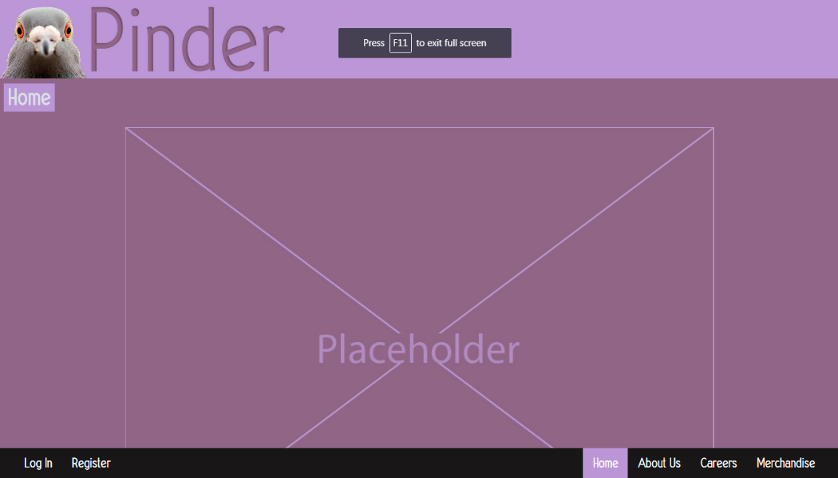

Some customers will be able to select from different properties:-

* Type of death
* Hitman choice
* Location of death
* Time of death (period in days)
* Possible disposal of body

Each item in these categories will have different point values and the customer will be able to choose upto a total of 100 points.

So choices for DEATH TYPE

* Suicide (15 points)
* Accidental hit and run (10 points)
* Sniper (25 points)
* Drowning (20 points)
* Petrol bombed (20 points)
* Rape and dump (10 points)
* Poisoning (15 points)
* Hanging (20 points)
* Electrocution (10 points)
* Accidental piano drop (15 points)
* Boulder crush (5 points)
* Elephant crushing you (20 points)
* Impalement (10 points)

## **Rat Torture (5 points)**

Type of hitman

* Posh hitman (30 points)
* Classy (25 points)
* Woman (15 points)
* Trans (20 points)
* Ladyboys (10 points)
* Trailer trash (5 points)
* Black  (10 points)
* White (20 points)
* Asain (30 points)

Location of death

* Bank (10 points)
* Skip (10 points)
* Ship (15 points)
* Sea side (20 points)
* Blackpool (25 points)
* Cornwall (5 points)
* Restaurant (15 points)
* Victim's workplace (25 points)
* College (30 points)
* Saw mill (20 points)
* Scotland (5 points)
* Bathroom (15 points)
* Kitchen (15 points)
* Wales (1 point)
* In an alley (5 points)
* Woodland (15 points)
* Moors (20 points)
* Zoo (25 points)

Time period to complete the hit

* 1 day (30 points)
* 2 days (25 points)
* 5 days (20 points)
* 1 week (15 points)
* 2 week (10 points)
* 1 month (5 points)

If disposal of body is required then charging an additional 15 points which will be a checkbox option next to type of death.

Drop down menus that give the customers different choices.

Input boxes that allow the user to input where the intended victim or victims will be at a certain time of day.

Upload option for if the customer can upload the victims general itinerary for the period of death.

Upload option of a photograph of the victim

No Training needed.

Initial Contract - 25k for initial contract

Extras DLC options

Extra points - 1k per additional 5 points

Planting evidence of another person's guilt (framing someone else) - 5k

Organised a party with 100 guests for your alibi - 1k

Social media pictures taken and uploaded as extra alibi evidence - £500

Social media with added videos as extra abili evidence - £750

Additional people - 10k per person.

While designing the HCI for create a contract I ensured that I used Principles (form follow function, constancy, colour and feedback), I used proximity from The Gestalt Principles and I ensured I kept the guideline in mind.

Form follow function: This principle that a shape of the object should primarily based on the intended function/purpose. An example of this is the button because we all know what the function of this button is. Therefore, we just click on the button without thinking.

Constancy: This principle is presented by keeping the text colour, layout and so on to be the same on all pages because this ensure that the user can easy follow your product. An example of constancy is Facebook because this social media will make sure they have kept all the pages the same so the user knows how to use it.

Colour: This principle is used a lot to make sure that the colours chosen for the HCI is suitable for all types of users because this can ensure that anyone can see the text with the chosen background colour without making it all fuzzy and difficult to see and read.

Feedback: This principle is receiving information on the project or how someone has performed because this will allow any improvements on the chosen subject. An example of this is a prototype because this will allow the users to give any positive/negative and how the improve the prototype.

Proximity: This principle is used to senses how far the objects are from each other (N/a, n.d.).. But in HCI design proximity is can mean how close/far away objects are from each other.

An example of this is iPhone and android apps because these will have the same amount of space with the apps from each other.

**What 3 function/features was used for creating a contract**

* Clear navigation
* contact information
* How the user want to kill their victim .

I selected clear navigation as this will ensure that anyone from low computer literate to higher computer literate will how to navigate throughout the whole system.

I selected contact information because the theme of the website is to hire a hitman so when the payment phase is where the contact information kicks in.

Final function is how they want to kill their target because they can select how pain the target can die. The user will be able to pick how the time period on the hit as they might want to kill the target in the next day or even a week because this will ensure they will have an option to pick when that person will die.

**Medium Prototype Design for Create a contract**

This was created on [mybalsamiq.com](http://citycollegeplymouth.mybalsamiq.com/), this was the basic design for the website because I wanted to ensure I knew what the website would look like before making the high tier prototype.

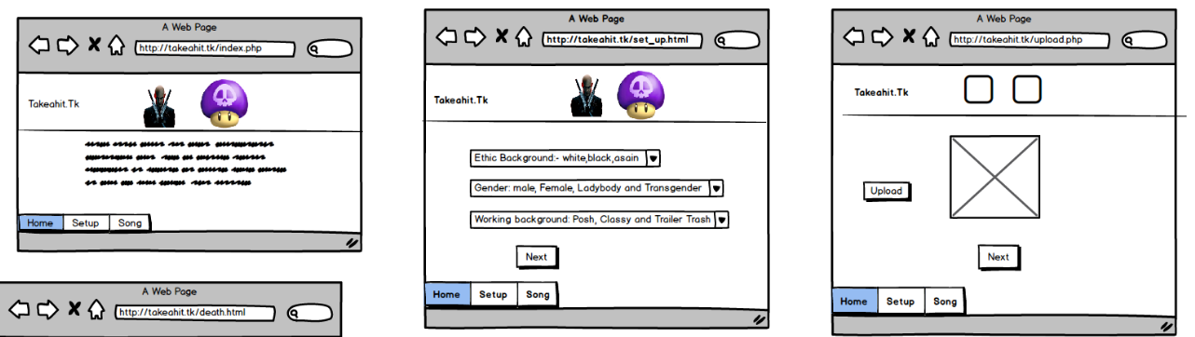

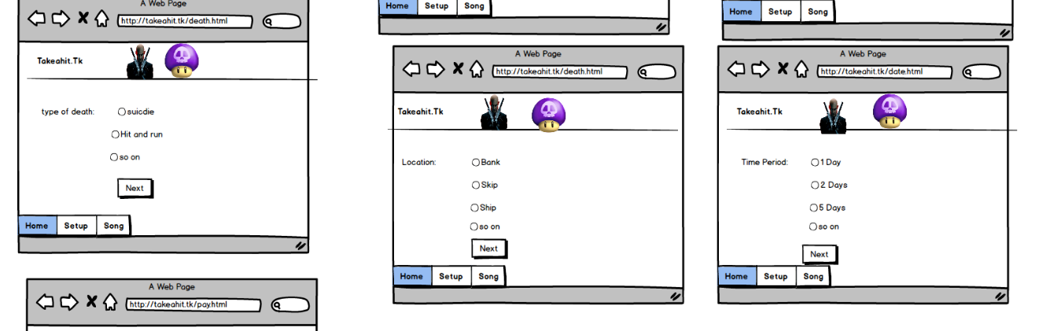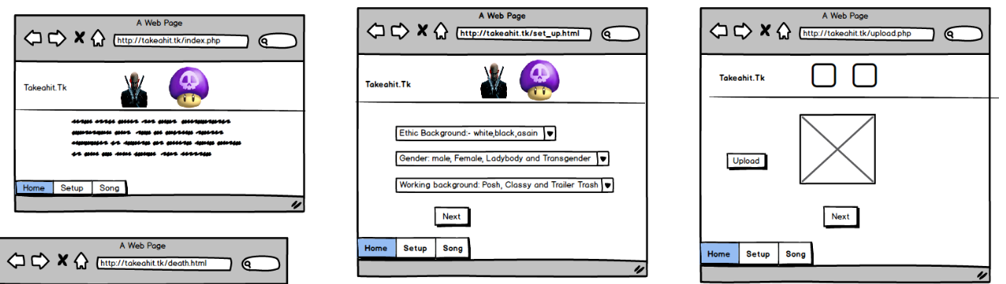



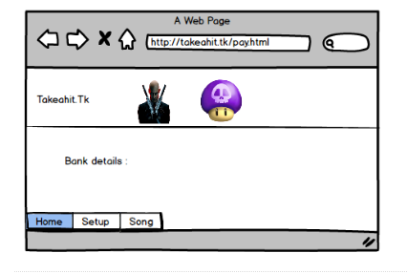

**High tier prototype**

I created this by html and CSS because this would allow me to get some good feedback because I can see if the website hits the correct criteria and see if the website is user friendly.

Therefore, putting the site live was the best idea because this will allow me to gather good/bad feedback on the website.

However most of the design is the same but there was a lack of text on the homepage. The other 2 buttons on the website are for the guidelines and feedback because this will be the easiest way for users to give me the feedback. To see the live site, it’s <http://takeahit.tk>.

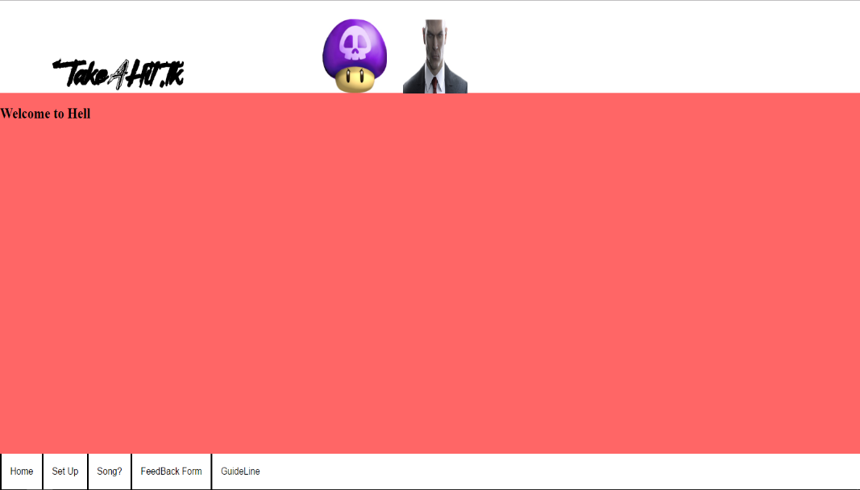

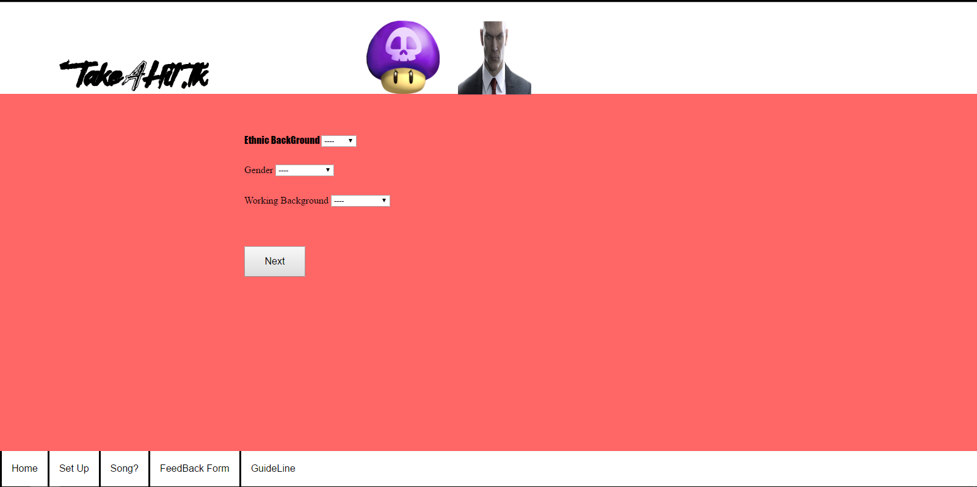

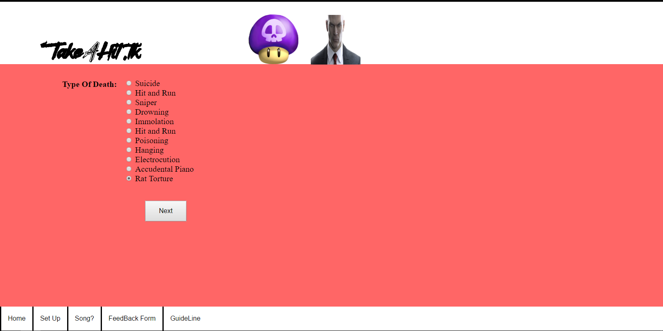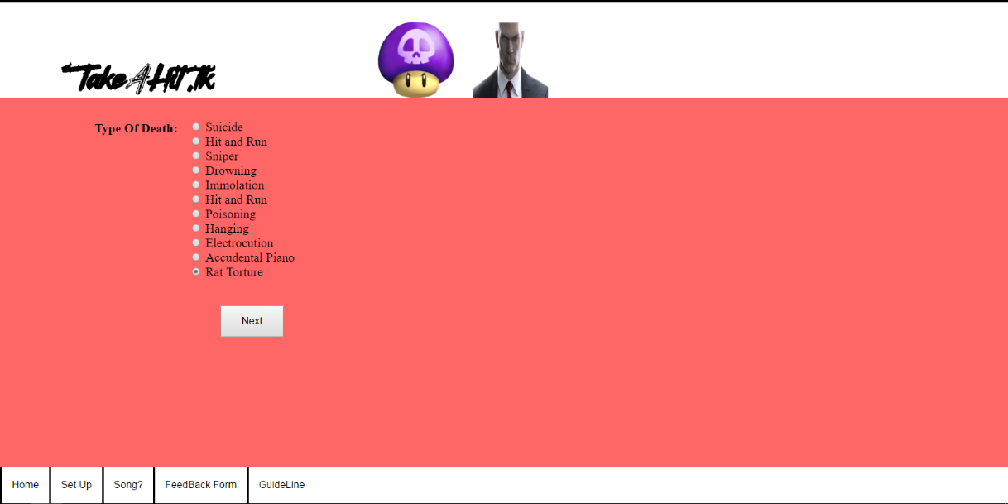

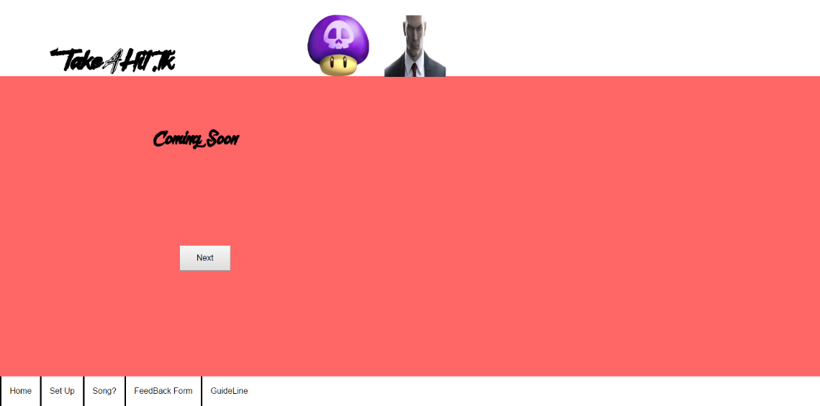

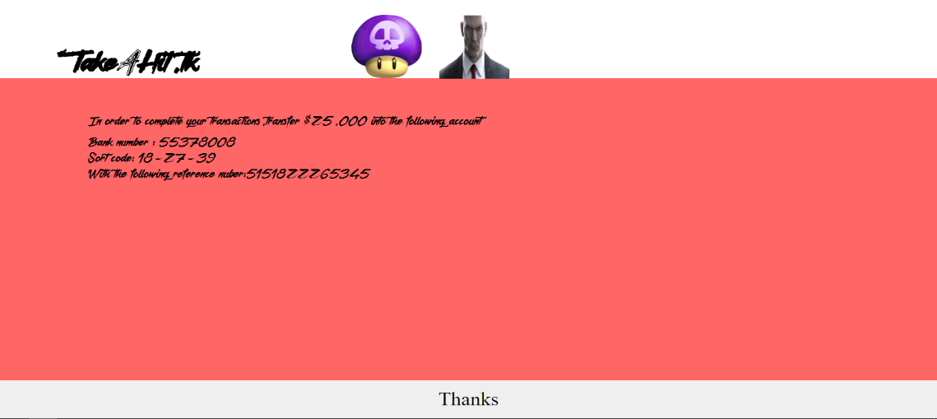

**Why did I chose this design?**

When designing and implementing this site, the first thing I did was go through the guidelines and broke it down because this ensured and helped me what designs principles to use and when to use them. I used the navigation at the bottom for all but payment page because in the guidelines the layout was based on pinder. But only changed it all to the left instead of 2 on the left and 4 on the right because I believed keeping to the left the best idea as was no login system onto the site.

I made sure I followed most of the guidelines however I left out some of the different types of death and location of death because it would just have been an endless list of many ways to kill them and what location to kill them in. Therefore, I included most of type of death and the location to kill them in. But in future I would include more types of deaths and locations because this is just in case the user want other ways to kill their victim and where to kill them.

The colour, font, logo and the lay out the design has been spot on with the whole website prototypes because these are the framework of the website but I had to change the size of the font, down to the reason it was just too small for users to read.

However, I believe looking back onto the website the font size was still a bit small because the font style made font size 38pt look smaller than the default font styles.

I used the drop-down menus for type of hitman because if I used radio buttons it would look very confusing on the user as they wouldn’t know what basic traits for the hitman they want.

But if I inserted check boxes for the hitman traits e.g. ladyboy, white and posh, I believe the users will just check all the boxes for their chosen hitman because common knowledge has told me that the user will not know what to do if they have multiple options while it’s not clear what they are clicking on.

The only sensible way for Hitman traits is the drop-down menu because this ensure that the user know what they are selection before they decide as each drop-down menu will the right information for them. an example of this will be Gender.

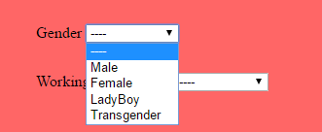This is an example of using the drop-down menu as inside gender you can select the 4 options for the gender of the hitman your hitman.

For the type of death, death location and the Time period I used radio buttons because humans only have one life so you can’t to kill one victim 1 month and 5 weeks as this is impossible to kill that same victim twice in a span of 2 weeks.

I made sure I used Proximity and efficiency because the made sure that I grouped all the radio buttons together on the respective page because this ensures that the user will be able to find how they want the victim to die. If it was all scatter around the website, this will not make the whole website efficient because half of the time, the user will be looking all other the place on the page just to find how they want the victim to die.

I also implement constancy onto my website because I want to ensure that my hitman website has constant layout of with all the pages, so anyone and everyone understand where everything and anything is in the same location. An example of this is navigation because this is always in the bottom left of the website to ensure the users know where it is. However, the payment page doesn’t have the navigation menu because as once the target is done. The user would need to type <http://takeahit.tk> and repeat the process all over again if they need to add a new victim.

**Evaluation for create a contract**

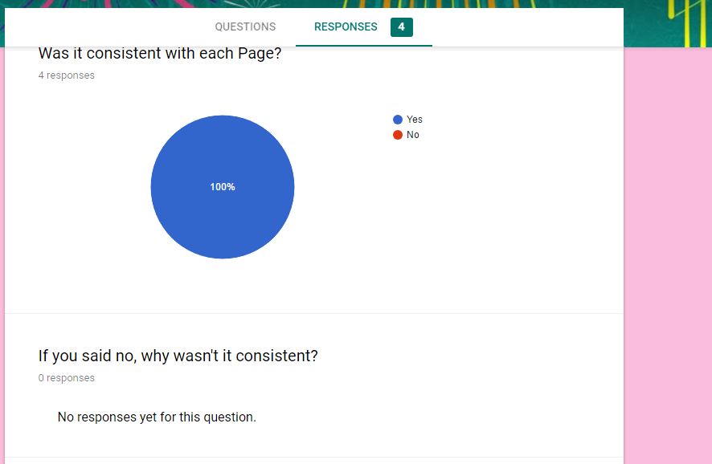

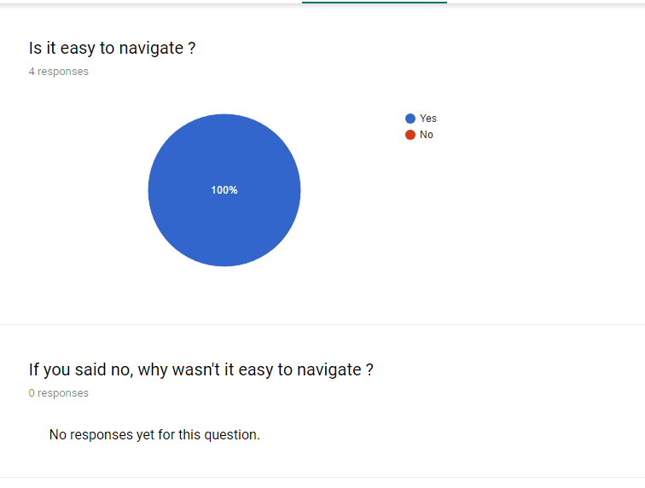

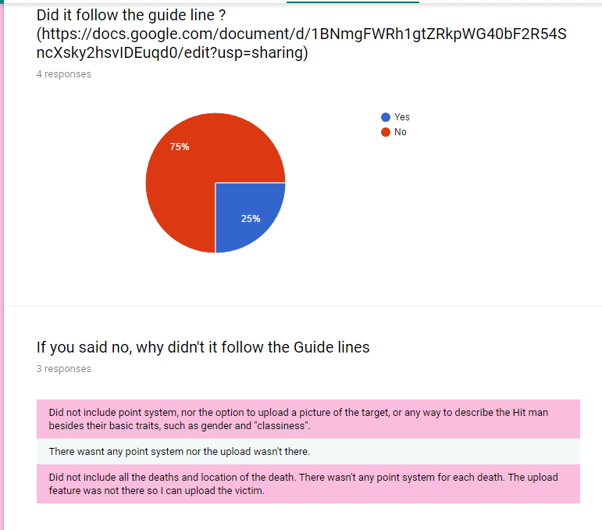

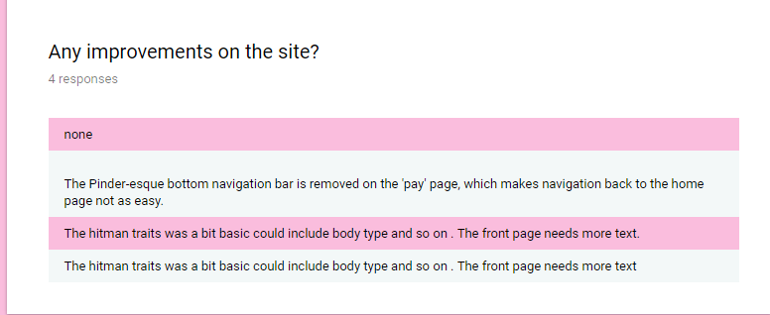

As you can see from the feedback from the users, the UI was overall positive but there were some issues and improvements that could/should be included. But I am happy that the Website was user friendly and easy to navigate because I was more worried if this UI was easy to use, as I have seen many websites that have failed or lost many users as the UI was too hard for them to use.

However, one of the main issues that the website did not follow the guild lines because the users did not see the point system that was used for guild lines, couldn’t upload an image of his/her target and just basic traits on the hitman.

The reason why I did not include the point system because without a log in system the points would not be on that user. Therefore, I had to get rid of point system until I know how to implement this feature without any hick ups.

I did not have the button for upload because it was not ready at this moment in time if I included a button for upload; I would believe that the users will think the button works, as it will follow the HCI principle for form follow functions. But in reality, the upload button did nothing, so I had to remove this feature when I made the site live.

But in further work and improve I would try and get the login to work and include that users’ points system, I would be able to add an upload system because this ensures that users can select their targets and win points to redeem for other killings.

The main reason why the hitman has got basic traits because if this was a real hit man site, the police would know what all the hitman would look like if there were more than just basic traits. However, for improvements I can add my traits for the hitman like hair colour, body build and so on this can ensure that the user can pick and decided what type of hitman they want expect just having the basic gender, ethnic background and working background.

When analysing the guidelines, the designs hit most of the criteria because I made sure that I included all the important information for the website.

However, I did not include the upload because when I was implementing the website I knew if I had the upload button, everyone would just click on it and this would end up the user being mad that this feature doesn’t work.

Also, I did not include the rewards users get when they hire a hitman because these rewards would give you a free or half price on kills. However, this system was not used because the was not log in system to track what points each user gets, therefore this option was scraped in the final design.

The Final change from the guideline was the text size because the guidelines wanted the text to be 15px but while implementing the design the text was too small for anyone to read. Therefore, I pick 38px for text for the final design because this was easier for the users to read .

Teapot?

**Spam Posting Design**

**The user requirements**

This website will allow users to upload multimedia (images, videos and music) onto their profile page in future updates the users will be able to view other people’s multimedia. The admins will be about to see what’s been uploaded onto the website for any bad content e.g. sexual picture this will only happen if police are involved.

**What HCI principles was used?**

While designing the HCI for spam posting, I ensured that I used HCI Principles (form follow function, constancy, colour and feedback), golden tringle, Proximity from The Gestalt Principles and followed the mid-tier design because this make sure I have a good idea what the final UI should look like.

Form follow function: This principle that a shape of the object should primarily based on the intended function/purpose. An example of this is the button because we all know what the function of this button is. Therefore, we just click on the button without thinking.

Constancy: This principle is presented by keeping the text colour, layout and so on to be the same on all pages because this ensure that the user can easy follow your product. An example of constancy is Facebook because this social media will make sure they have kept all the pages the same so the user knows how to use it.

Teapot?

Colour: This principle is used a lot to make sure that the colours chosen for the HCI is suitable for all types of users because this can ensure that anyone can see the text with the chosen background colour without making it all fuzzy and difficult to see and read.

Feedback: This principle is receiving information on the project or how someone has performed because this will allow any improvements on the chosen subject. An example of this is a prototype because this will allow the users to give any positive/negative and how the improve the prototype.

Golden tringle: This principle was used for market research as this will see where on the screen the user looks first. The users normally look at the top left because from the research from Enquiro (mgeale, 2009) did a study with heat patterns for where the users eyes look first on a website.

Proximity: This principle is used to senses how far the objects are from each other (N/a, n.d.). But in HCI design proximity can mean how close/far away objects are from each other. An example of this is iPhone and android apps because these will have the same amount of space with the apps from each other.

**What 3 functions/features used for spam posting**

* Login
* Register
* Upload

I selected login as my first function/feature because without this the user will not be able to upload any multimedia on their page and this always makes sure the database will know who upload what image, video and music. So, when that user logs in again all their images, videos and music will still be there waiting for them.

I selected register as my second function/feature because this will allow the user to create an account with this site. As the database will pick up and store that new users username and password, as this will allow them to log in when they are next on this website.

Final function/feature is Upload as this will be essential because if the user needs to upload their multimedia on to the page and this will keep everything that has been upload. This will also be connected to the database to ensure they will not lose any data that has been stored.

**Medium Prototype Design for Create a contract**

This was created on [mybalsamiq.com](http://citycollegeplymouth.mybalsamiq.com/), this helps me to design a basic website because this will give me a basic outline for the website and when the high tier prototype comes I can improve the website from the feedback that I will receive.

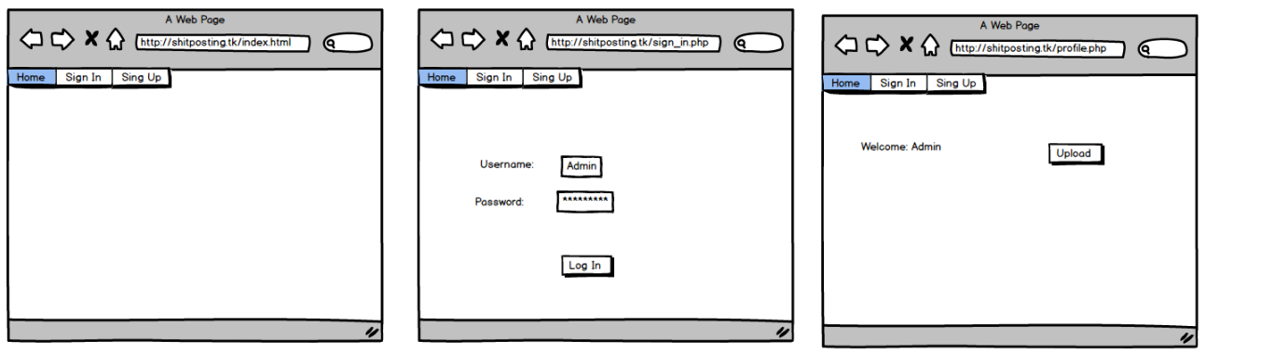

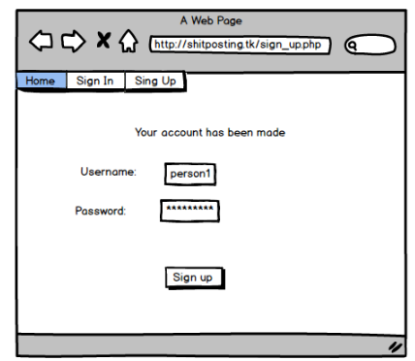

**High tier prototype**

I created this by html and CSS because this would allow me to get some good feedback because I can see how/where the user looks first and build it from there. This is will also help if the website is user friendly. Therefore, putting the site live was the best idea because this will allow me to gather good/bad feedback on the website.

However most of the design is the same but there was a lack of text on the homepage. The other buttons on the website are for the feedback because this will be the easiest way for users to give me the feedback. To see the live site, it’s http://spamposting.ml/menuTL.html.

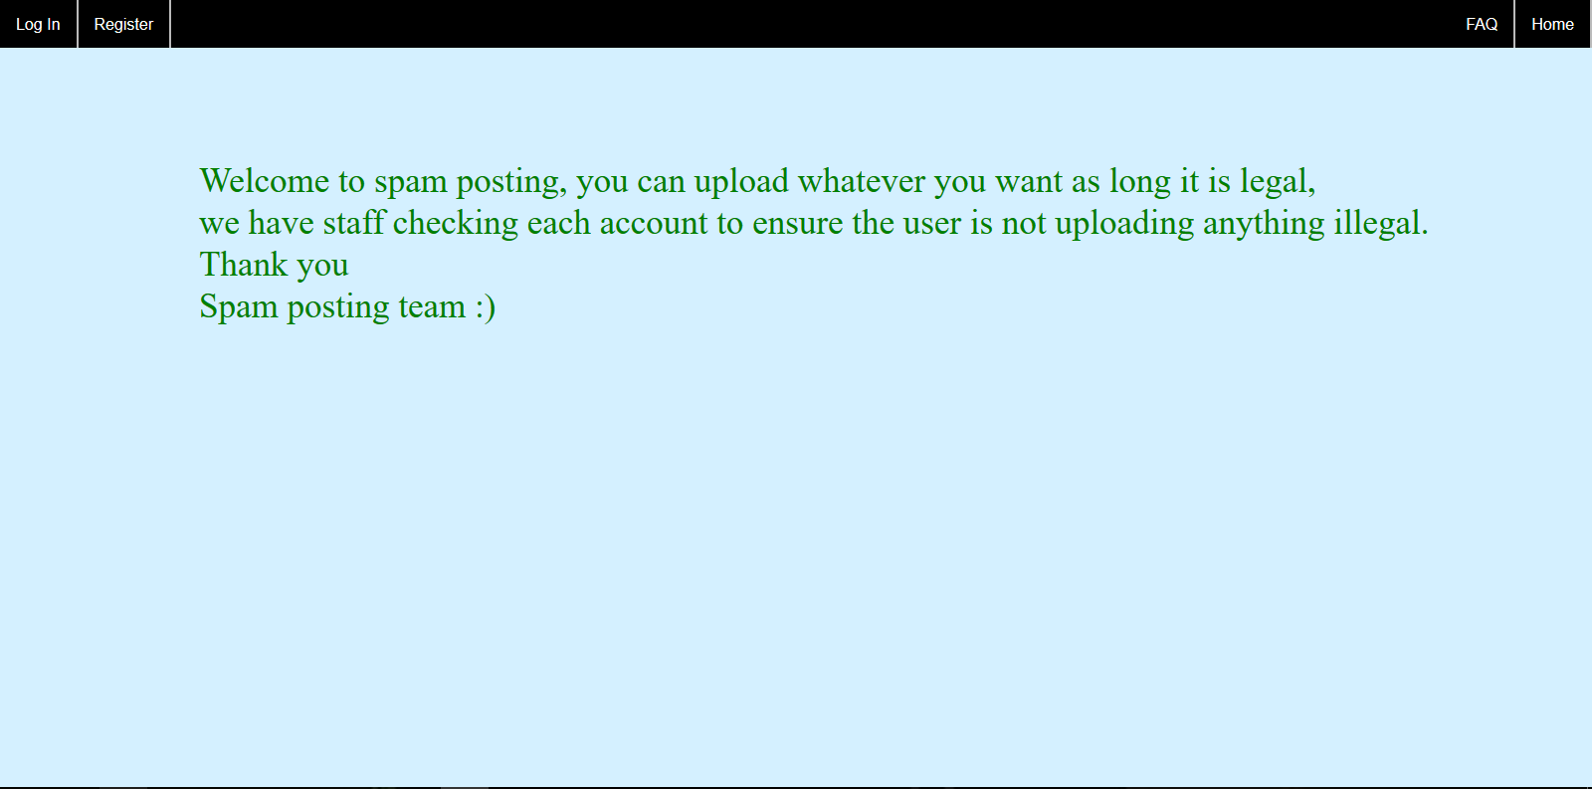

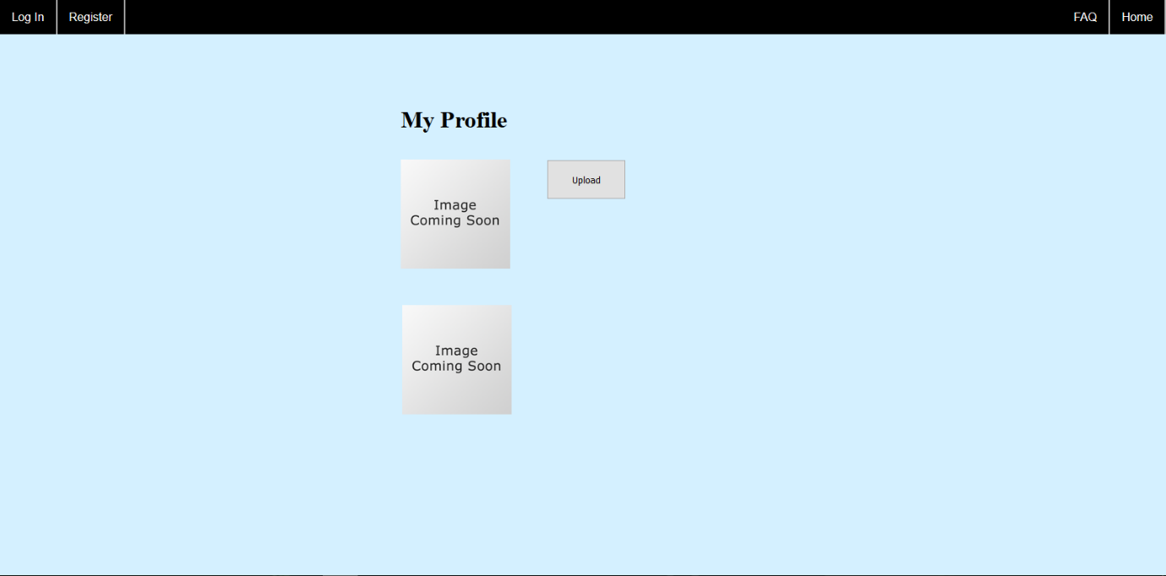

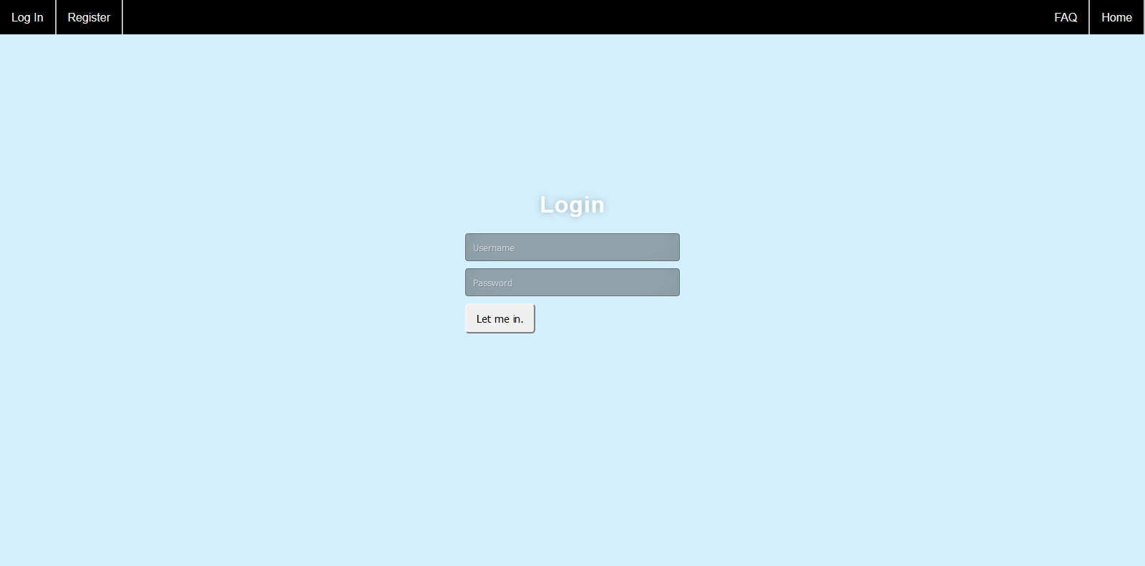

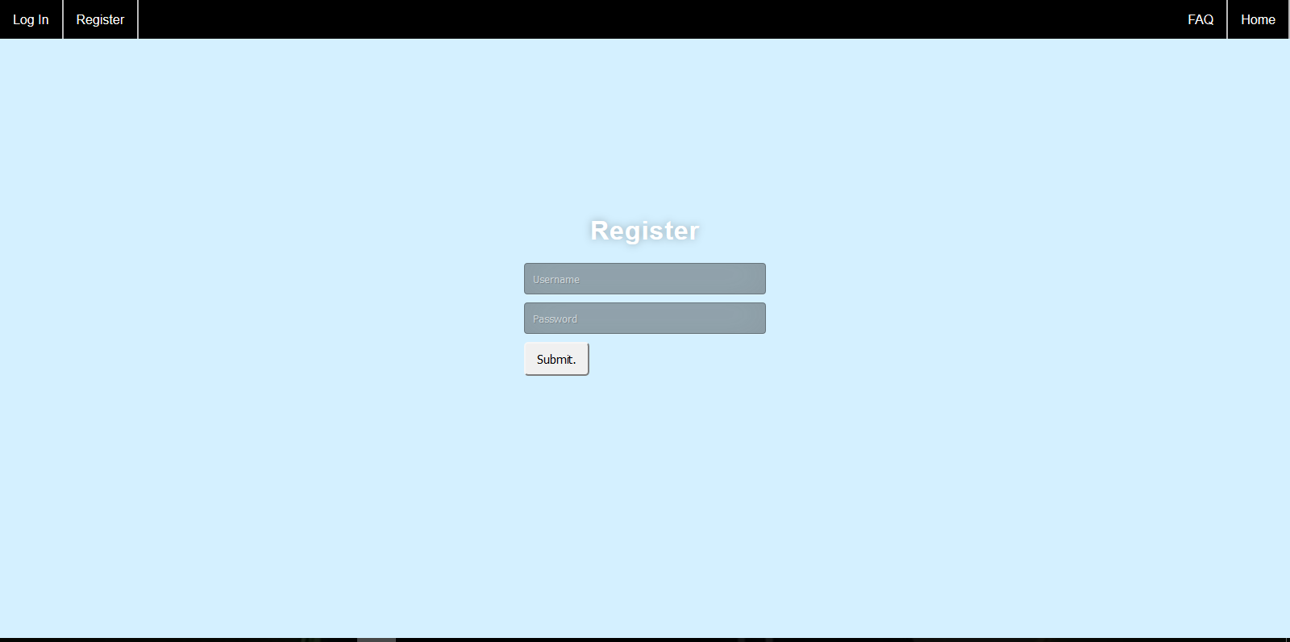

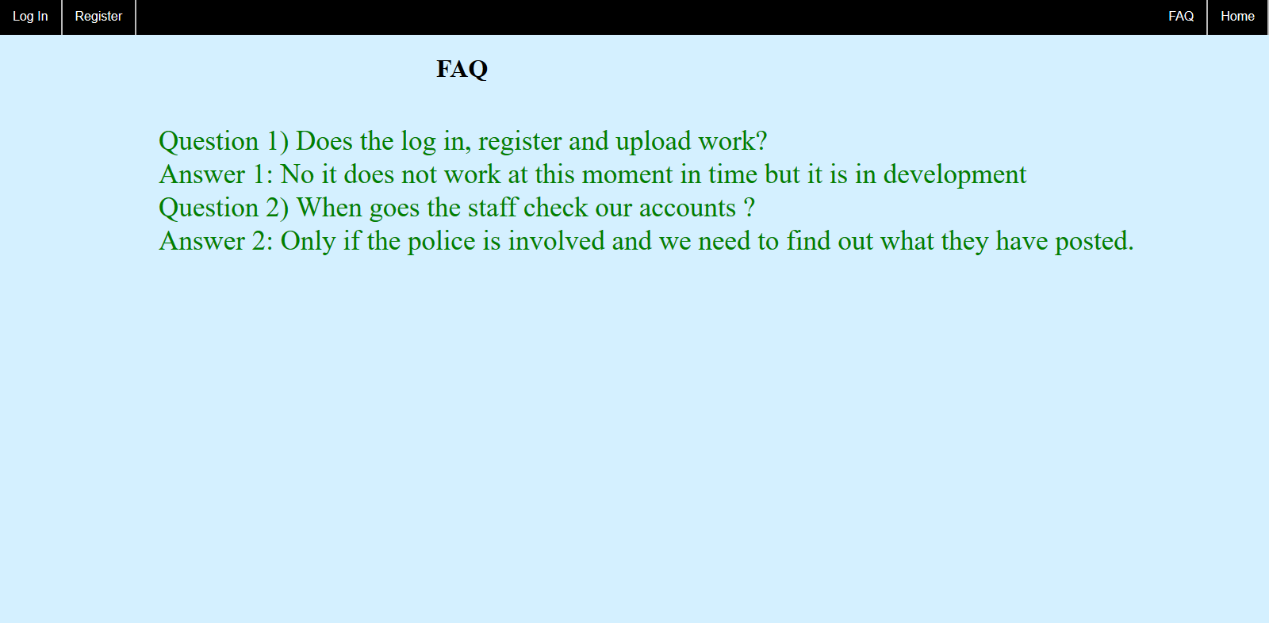

**Why did I chose this design?**

The whole design was from feedback because this will allow me to understand what the user looks at first and build the website from there because I did not have a set of rules/guidelines to follow when designing and implementing the whole website.

Before making the final prototype for spam posting, I first made some prototypes that will have the menus in different locations because other may years of websites they have change the navigation bar an example of this is the navigation bar at the bottom. After the response of the 4 users 50% of them look at the top left first, this is called the golden tringle or it is called the “F” form. To look at the HCI designs. The URL is <http://hcidesigns.tk/Main/index.html>

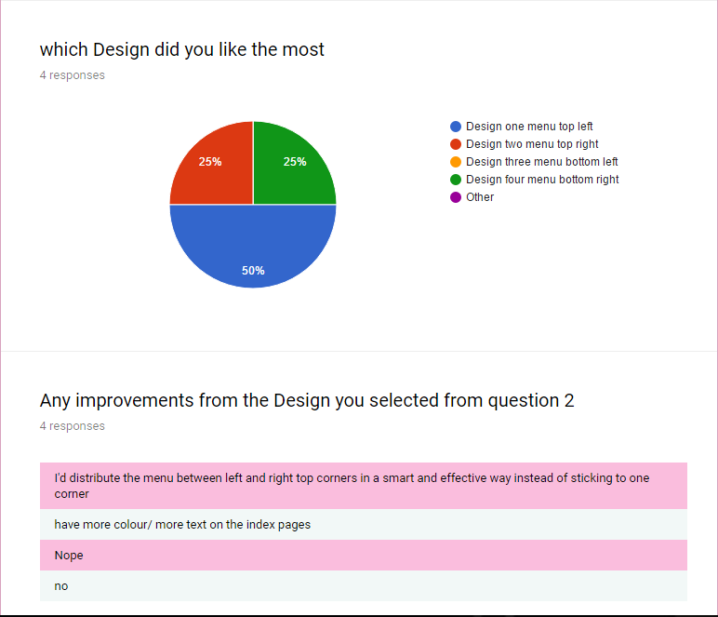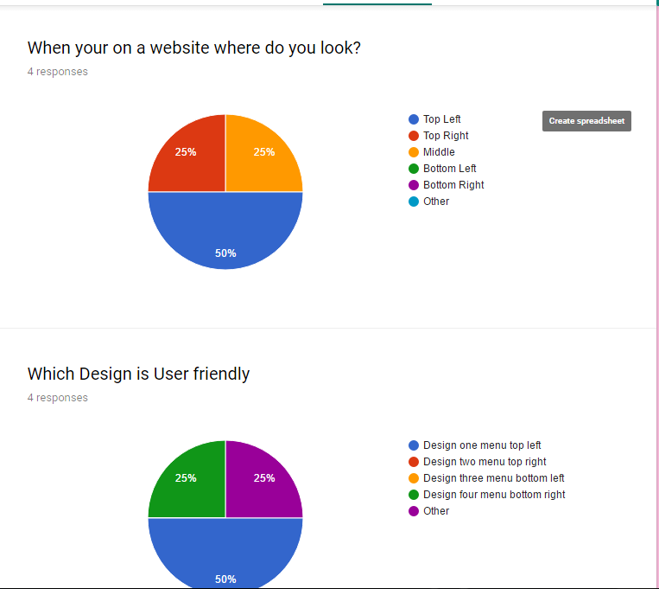

This is my feedback form for the HCI designs, as you can see I did some test to see where the user look first on website, which design is user friendly, which design did they like the most and any improvements for the design they liked.

I made sure I used Proximity because I ensured to been the same spacing with the upload with multimedia, as this would have the same spaces as Apple/android would use for application spacing. If the spacing was all random, this wouldn’t be efficient because the users would need to adjust for a good few weeks. This might be an issue because this might not ruin my website if I did not use proximity as a principle.

I used the golden tringle because from my feedback 50% of the responses look at the top left when they are first looking at the website, from research users are more likely to look from the top left first, websites still use this method today, therefore this principle will be useful ensuring the website will be user friendly and easy to navigate.

https://i.gyazo.com/47f99f8e03d77bdfe06b23bddea243f0.png I also implement constancy onto my website because I want to ensure that my spam posting has been constant with the layout for all the pages because anyone and everyone understand where everything and anything is in the same location. An example of this is navigation because this is always spilt from top left and top right because lots of websites use this outline.

Figure 1; (zuckerberg, n.d.)

As you can see from Figure 1, Facebook use spilt menu system because as you can they have Facebook logo and the search on the top left and then they got

the home, the user, mail and etc on the right. I used this function because everyone uses Facebook, therefore the users will not need to relearn anything.

**Evaluation for Spam Posting**

**Evaluation for Spam posting**

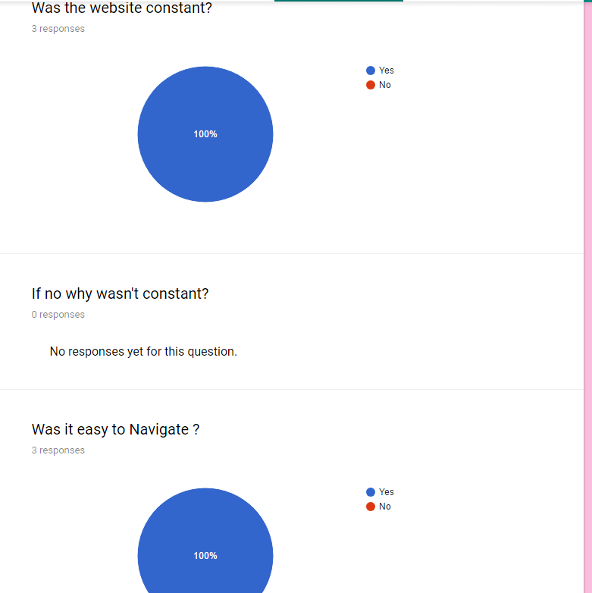

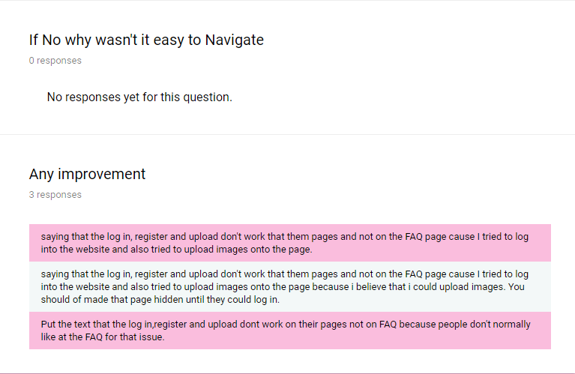

As you can see from the feedback from the users, the UI was overall positive but there was one main improvement that is still in development. But I am happy that the Website was user friendly and easy to navigate because I was more worried if this UI was easy to use, as I have seen many websites that have failed or lost many users as the UI was too hard for them to use. Another issue that the users ran into was the form follow function as they thought upload, log in and Register works but I did put why it would not work in the FAQ but from my finding the users did not read that page.

One of the improvements was that the login, Register and upload is not live because this is still under development and it will be live before 9th of June 2017. This is my main improvement however there is a couple of improvements that I want to use.

I allowed users to see what the upload page looks like because this ensure that the user is happy how the page likes before it is live. However, I ran into the problem of the form follow function because people thought the upload, log in and Register works but I should have been clear on them pages and not on the FAQ page. But in future I will correct that mistake and put it on their pages.

Other improvements will include a voting system, sharing multimedia to each other on the site and sharing multimedia to twitter or Facebook having these 3 new features was will amazing for me and the website because this can show I will be capable to use most common features from websites like Facebook, Reddit and imgur. As these 3 websites uses voting system in some way for Reddit it’s for up voting posts and the highest voted post go onto the main page of the site because this will show all the user what was top voted for the day.

**Analysing the medium designs to final designs**

While analysing both medium tier designs to final designs, there are 2 differences from both designs. The first difference is the navigation bar because it was all to the left but when I received feedback, the users rather want the navigation bar to be distribute to the left and right. Therefore, in the high tier prototype I distribute the navigation. The Second main different is the profile page because in the medium tier, there is no place holder and it looks bare so the user/stakeholders would not know where the multimedia will be placed. Therefore, I fixed this problem when implementing the website because this will help me understand the Proximity of the multimedia and the best place to place the placeholders.

Teapot ?

**Was these Two Techniques useful for evaluation on the prototypes?**

Feedback form was a very effective because this allows me to understand if the users can easy use the website and if there were any issues/problems with the whole website. I believe this was a good technique to use as this will give me some positive feedback from the user and ensure that the users know how to use this website and it was easy to use.

Analysing Guidelines(contract)/Designs (spamposting website), this was effective because I can compare the designs to the final form. However, I believe this was a bit of a problem to use this technique as this there is only one input that was myself. This can make a huge problem if this was a real website because I don’t know if the website was easy to navigate, kept to the original guideline/designs or if there was any improves.

Another reason why analysing guidelines/designs wasn’t up to par because this technique only works for create a contract as this is the only website that used guideline. Therefore, the spam posting was pointless to use for analysing as more of the improvements was coming from the users. I just knew that spam posting was for uploading, logging in and signing up onto the site.

One Technique I should have used instead of analysing the guidelines/designs was observing over people shoulders because this can see if there are any problems of them using this website or if there was any delay on the user interacting with the website. An example of this is taking 20 second to find the navigation menu.

# Bibliography

mgeale. (2009, 09 23). *bruceclay*. Retrieved May 18, 2017, from /bending-the-golden-triangle/: https://www.bruceclay.com/blog/bending-the-golden-triangle/

N/a. (n.d.). *gestalt_principles*. Retrieved May 12 , 2017, from http://facweb.cs.depaul.edu/sgrais/gestalt_principles.html: http://facweb.cs.depaul.edu/sgrais/gestalt_principles.html

figue 1: zuckerberg, m. (n.d.). *Facebook*. Retrieved May 18, 2017, from Facebook: facebook.com